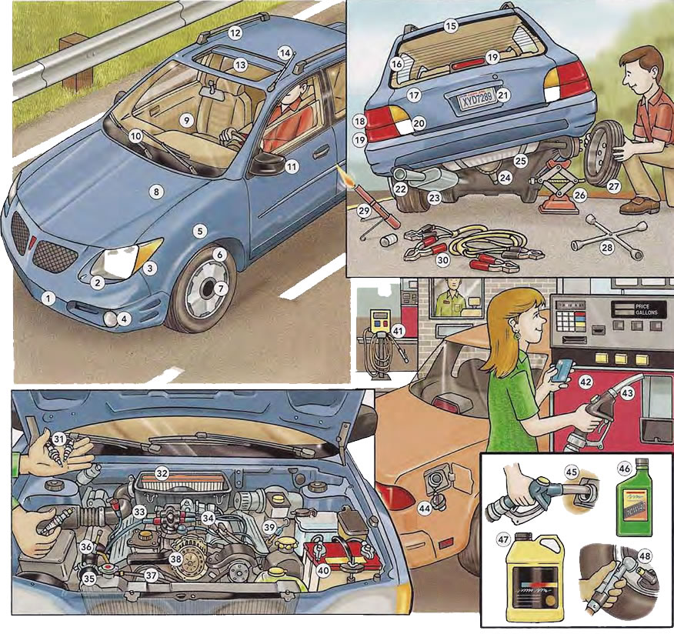

air filter ___ alternator ___ battery ___ dipstick ___ engine ___

fan belt ___ fuel injection system ____ radiator ___ radiator hose ___

spark plugs ___



boot ___

brake light ___

exhaust pipe ___

flare ___

fuel tank ___

jack ___

jumper cables ___

lug wrench ___

muffler ___

number plate ___

rear defroster ___

rear window ___

reversing light ___

spare tyre ___

tail light ___

transmission ___

**TEACHER**

**BULBS CONDITION FLUID NECESSARY PEDALS PLUGS**

**PRESSURE REFILL**

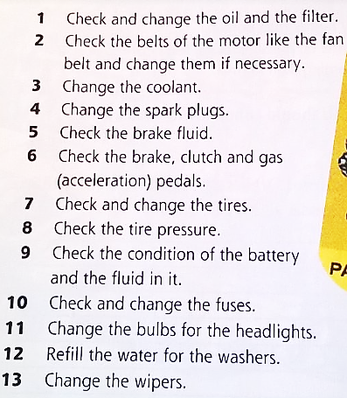

What do you use to check the oil level? ………………………………………………………………………..

What do you use to change a tyre? ………………………………..………………………………………………..

The tyre pressure is too high or ………………………...

What do you use to jump-start your car? ………………………………………………………………………..

What do you use to remove ice from your rear window? ………………………………………………………………………..

What do you use when you have a flat tyre? ………………………………………………………………………..

It has white light. ………………………………………………………………………..

**Bumper stickers are very popular in the US, they deal with politics, important matters or they are just plain funny!**

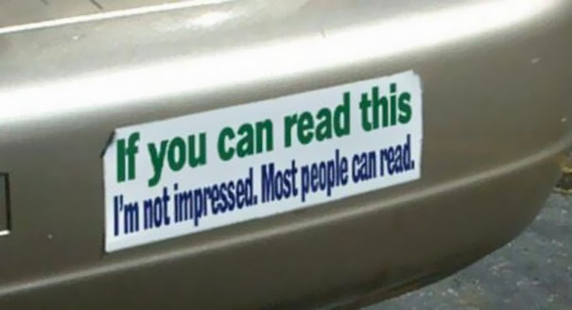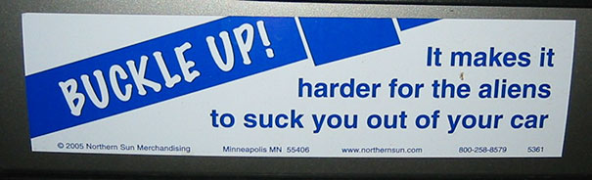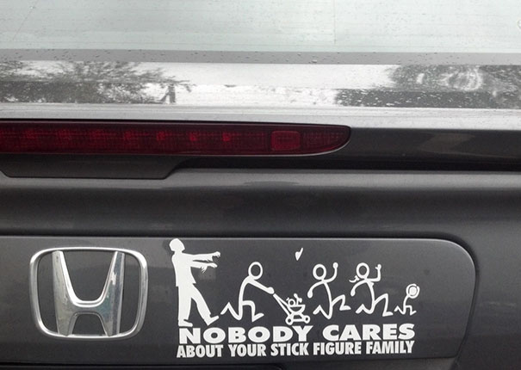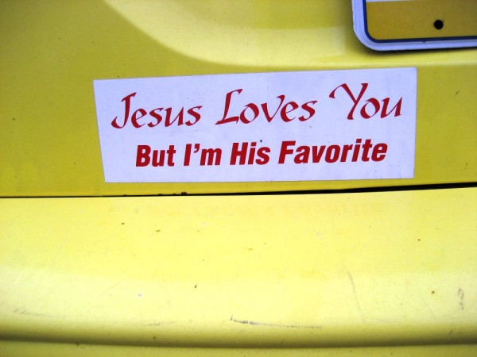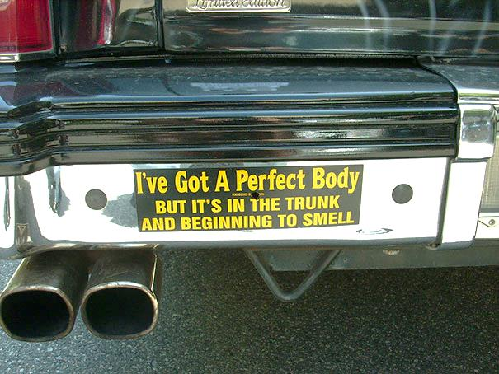

15 rear window

16 rear defroster

17 boot

18 tail light

19 brake light

20 reversing light

21 number plate

22 exhaust pipe

23 muffler

24 transmission

25 fuel tank

26 jack

27 spare tyre

28 lug wrench

29 flare

30 jumper cables

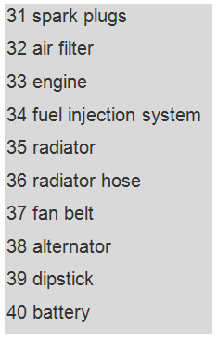

**TEACHER**

**11 BULBS 9 CONDITION 5 FLUID 2 NECESSARY 6 PEDALS   
4 PLUGS 8 PRESSURE 12 REFILL**



What do you use to check the oil level? ………………………………………………………………………..

What do you use to change a tyre? ………………………………..………………………………………………..

The tyre pressure is too high or ………………………...

What do you use to jump-start your car? ………………………………………………………………………..

What do you use to remove ice from your rear window? ………………………………………………………………………..

What do you use when you have a flat tyre? ………………………………………………………………………..

It has white light. ………………………………………………………………………..

**Bumper stickers are very popular in the US, they deal with politics, important matters or they are just plain funny!**

