**Look at the pictures and name as many external and internal car parts as you can.**

I.

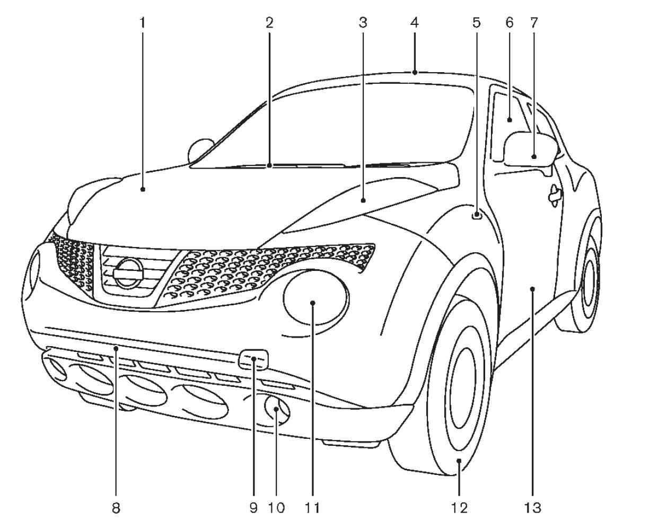

|  |  |  |  |
| --- | --- | --- | --- |
|  |  |  |  |
|  |  |  |  |
|  |  |  |  |
|  |  |  |  |
|  |  |  |  |
|  |  |  |  |
|  |  |  |  |

**Words for reference:** tires; windshield wipers; sunroof/moonroof; side marker indicators/turn signals; hood/bonnet; side turn signal lights; windows; tow hook; front bumper; fog lights; headlights; outside mirrors; doors

II.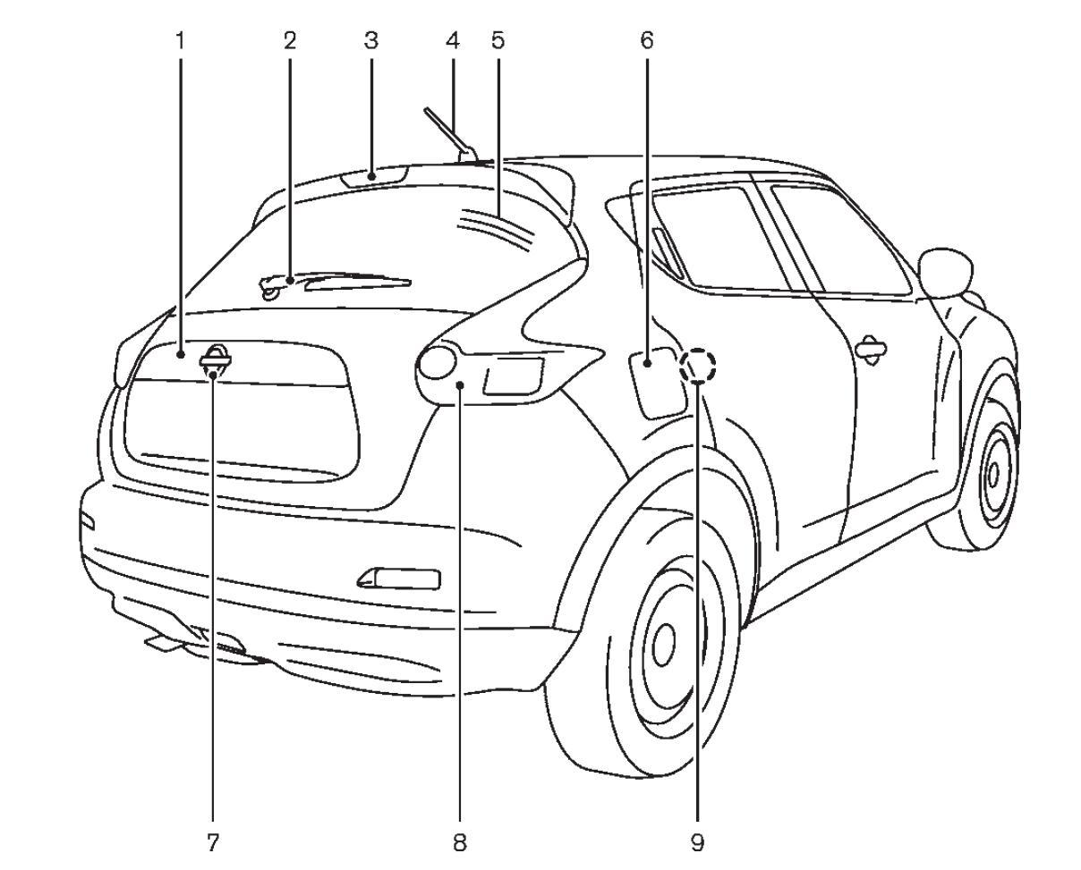

|  |  |  |  |
| --- | --- | --- | --- |
|  |  |  |  |
|  |  |  |  |
|  |  |  |  |
|  |  |  |  |
|  |  |  |  |

**Words for reference:** rear window wiper; rear window defroster; rear lights; boot/trunk; stop/braking light; fuel-filler door; rear view camera; antenna; rear door

III.

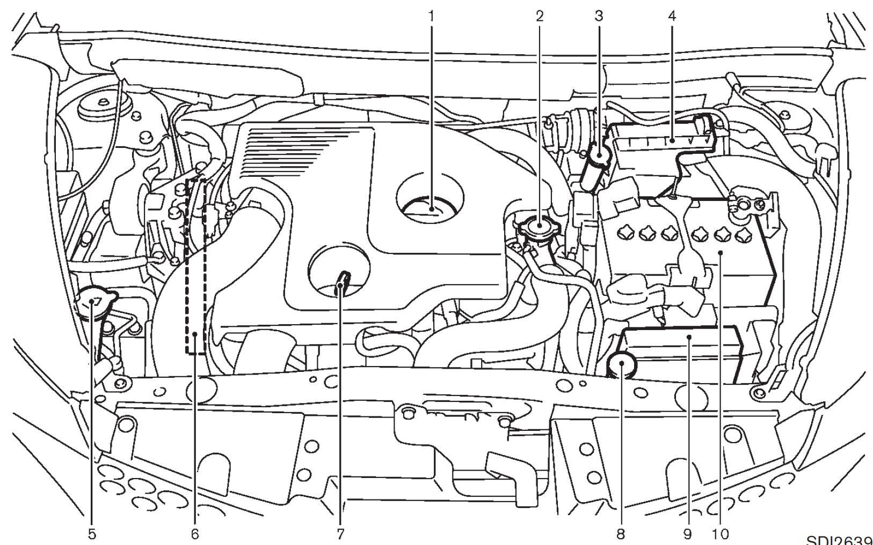

|  |  |  |  |
| --- | --- | --- | --- |
|  |  |  |  |
|  |  |  |  |
|  |  |  |  |
|  |  |  |  |
|  |  |  |  |

**Words for reference:** air cleaner; engine oil filler cap; engine drive belt location; radiator filler cap; brake and clutch fluid reservoir; engine oil dipstick; engine coolant reservoir; fuse/fusible link holder; battery; window washer fluid reservoir;

**2. Label the types of car.**

**Words for reference:**hatchback, convertible, coupe, estate car/station wagon, pick up, saloon/sedan, SUV (sports utility vehicle), limousine, sports car, truck, van

a) 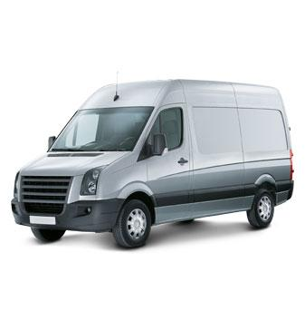 b) 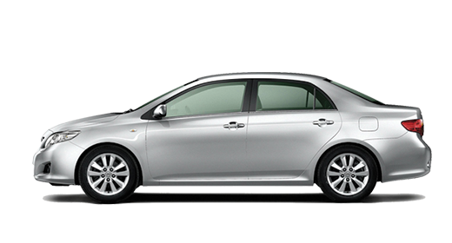

c) 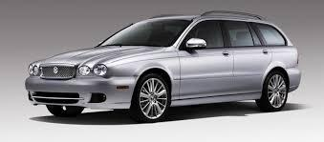 d)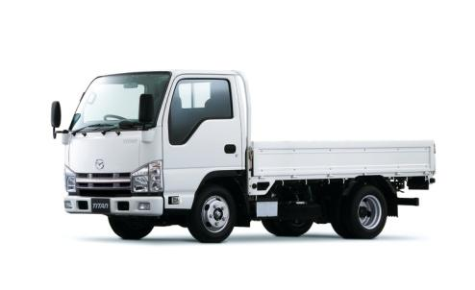

e) 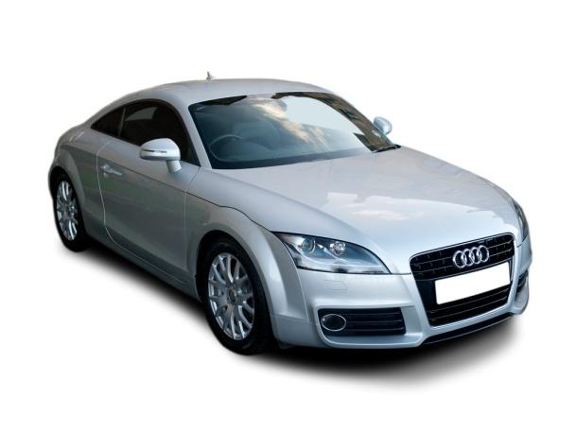 f) 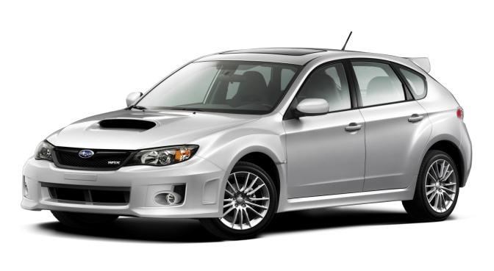

g) 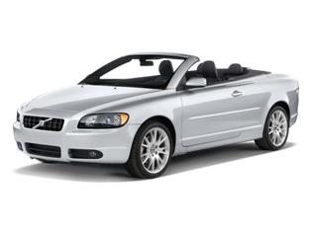 h) 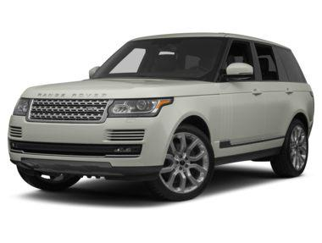

1. 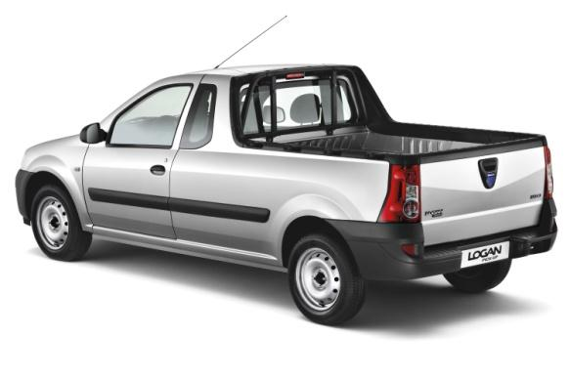 k) 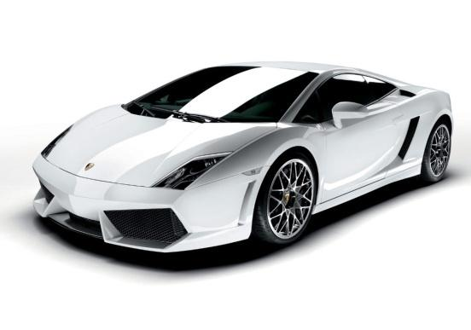

l) 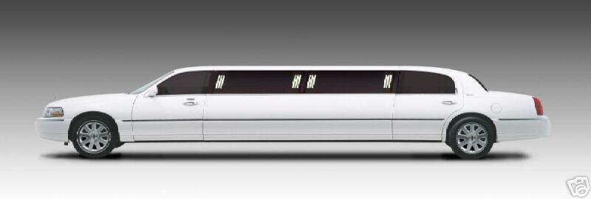

**3. Name cars that fit the description.**

Which car(s)

* is/are good for driving on bad roads?
* has/have low fuel consumption?
* is/are good for transporting things?
* is/are perfect for hot, sunny weather?
* has/have lots of room for passengers?
* is/are good for a large family?
* can carry heavy loads?
* is/are ideal for small parking places?
* has/have only one passenger seat?
* is/are not suitable for everyday commuting?
* is/are not suitable for large families?
* has/have enough boot space for several suitcases?

**4. What type of car would you prefer to drive in Grodno? Why?**

**5.** **What do you think is the best car for a big city resident? Read a few people’s comments below. Do you agree with them? Can you think of some other important features of a “big city” car?**

**Oliver, 21, UK:***In a big city, you need something practical but I personally still need something fun. Maybe a Golf GTI would be a good choice - it's quick and fun but small enough to park in crowded streets.*

**Filipp, 31, USA:** *My primary cause for concern in a big city would be a lack of space (for parking, maneuverability, etc), so it would have to be a small car. So my choice in a large city would be a FIAT 500 Abarth - it’s tiny, handles well and is fast enough to be fun outside of the city as well*.

**6. Read the interview and answer the question: What is needed to make sure that a car is ready for fall (autumn) and winter?**

- We are Best Auto Service Center here in Tannersville. Time to talk about getting your car ready for the fall and the winter, things we need to do. Joining me is Tom Sforza. Tom, when they bring their car in here, you're going to get it prepared for them, for the fall and winter driving. What are the things that you start to look for?

- Well, we want to check the wipers, the hoses, the belts, want to make sure that the tires are OK, brakes, undercarriage is safe...um...all the fluids: we want to do an oil analysis test - we'll do a free oil analysis test, make sure all the fluids are OK for the winter, antifreeze is big...um...want to check all those things and make sure the car is OK for the winter months. Battery needs to be load tested, 'cos a lot of times batteries fail and people don't know it until they go out and the car click-click...you know, they hear a click-click. So, we want to try and prevent that, you know.

- Probably one of the worst times to have your battery go is in the dead of winter...

- Ice cold, yeah...exactly.

- It's cold and you're stuck somewhere, right?

- Let's talk about that fluid analysis that you do. That is very interesting 'cause you can show them visually how their different fluids look.

- That's right. We take a spot of each fluid - power steering, brake, transmission, differential - and we show the customer right on the card if the oil is good or if the oil needs to be serviced, so they can see for themselves that it's OK...either it's OK or it needs to be serviced.

- OK. Now, we talked about tires: very important, especially for winter driving in the Poconos1, but besides having a good tire, what about what you put in it, as far as air?

- What we like to do, George, we like to use nitrogen, 'cos...'cos nitrogen is drier. It's, uh, air contains moisture so it's going to go up faster, so it's not going to be as consistent as nitrogen, alright...the pressures go up. Also the molecules in the nitrogen are bigger, so they're not going to leak out or permeate out of the tire faster. And being that the tire is operating at the right pressure, the customer will get better fuel mileage.

- Wow, that's all good stuff. When we talk about tires, I guess wheel alignment is also something very important?

- Absolutely, that's true. Especially in the Poconos, now, you...you know, the roads [are] not the greatest, so we like to get an alignment...I would recommend at least two a year, if not more if you hit a serious pothole, it should be inspected, it should be checked, you know. So, that goes along with the tires, that...the...the alignment.

- Now, here at Best Auto Service Center you've had 0% financing for as long as I can remember...

- Yes.

- ...but let's talk about something new: no credit financing?

- Yes, George, it's new, we've had it maybe a month. [If] the customer has bad credit or no credit, OK, we can get them financing on mo[st]...most of the time we can and it's called "no credit check financing", so there's a series of things, a form we have to fill out, we submit it and then they get their car fixed.

- Wow, that's super. No reason to put off getting those car repairs that you need now.

- Absolutely not, yeah...so you...there's no excuses now, you know, we can...we do it all, like to take care of our customers.

- Now, you service, of course, brand new cars...

- Yes.

- ...used cars, it doesn't matter.

- Everything. Brand new, we can do the maintenance on the brand new vehicle, which is not a problem. We...through Run-Rite, they also, the cu...customer on a brand new car will get a warranty through Run-Rite...

- Right.

- ...on every one of their systems, you know, whether it's transmission, brake, cooling system - as long as they service it here, we have a record of it, they will be covered under Run-Rite.

- Good. Alright. For more information, how do they find out about Best Auto Service Center?

- They could reach us on the web at www.bestautoservicecenter.com or they can call us at 570-688-2378. We are also on Facebook, as well.

- And you're located?

- Uh, we're right in Tannersville, right on 611, right across from Friendly's Ice Cream. Look for the big AC Delco building.

**7. Read the text again and answer the following questions:**

1) What is fluid analysis? What fluids are being checked?

2) What do the mechanics put in tires? What for?

3) How often does Tom recommend having your tires aligned?

4) Can you have your car serviced if you have a bad credit history?

5) Does the shop service only brand new cars?

6) How can you find *Best Auto Service Center* online?

**Careers in Automotive Industry**

1. **Why did you choose to study automotive service?**
2. **Do you believe it was the right choice?**
3. **What do you know about the following jobs?**

* Automotive Service Technician
* Service Advisor
* Automotive Engineer
* Vehicle Sales Manager

1. **Working in pairs, develop a Top-5 list of auto-related jobs you think are most exciting. Then compare all the lists in the classroom and vote for the final Top-5.**
2. **Read the extract from the article published on *Jalopnik.com* and compare your final list with the one presented in the article.**

Raphael Orlove What’s The Best Job In The Automotive Universe?

You've always dreamed of getting into the car industry, but you don't know where to start. *Jalopnik* readers have found the greatest car-related jobs you should kill to get.

**5) Supercar engine builder**

**Why it's so good:** Factory work for most automakers is rather difficult in the loud conditions, and fast pace of the line. Exotic car manufacturers, by contrast, invest heavily in clean, orderly, more slow-paced factories, like the *OCD Wonderland* at McLaren. Assembling engines all day in there would be quiet, calm, and something you could enjoy.

**4) Classic car restorer**

**Why it's so good:** You spend your whole day with dream cars, bringing them back to original condition or better. Well, you don't get to spend all day, as you're self-employed. But this also means you're going to have to deal with bad customers, guys who leave their car at your shop for months and never return your calls, and take the stress of staying profitable with your own business.

**3) Skunkworks2 engineer**

**Why it's so good:** Being an engineer in the massive bureaucracy that defines most car companies can be extremely degrading, with years going into refining out-of-sight parts. Working at a skunkworks division, like BMW M, AMG, or SRT allows you to make visible progress to a car design, and what you're doing is making some of the fastest, coolest cars in the world.

**2) Car designer**

**Why it's so good:** The starting pay is bad and you will spend your entire career fighting with corporate bosses who want to economize your designs into something less radical and expensive to produce. But it will all be worth it to see your work used by millions of people, making their lives better with good design.

**1) Automotive journalist**

**Why it's so good:** Oh, I'm sorry, I couldn't possibly borrow the Aston Martin Virage this weekend. No, not even if you drop it off at my house, I simply don't have time. Call me back when the new Vanquish comes out, I think I'll be available then.

1. **Match the jobs with reasons why they are on this list.**

|  |  |
| --- | --- |
| 1. Automotive journalist | a) You can avoid the noise of a large auto manufacturing plant |
| 2. Skunkworks engineer | b) You can enjoy working with beautiful old cars |
| 3. Classic car restorer | c) You can see the result of your work on the road one day |
| 4. Car designer | d) You can test-drive lots of exciting cars |
| 5. Supercar engine builder | e) You can work in a small team of really creative people |

1. **Would you like to try any of these jobs yourself? What about them interests you?**
2. **Read how employees describe their jobs. Make sure you understand the underlined words.**

I’m an office worker in a large car manufacturing company. It’s a **nine-to-five job** with regular working hours. I’m a secretary, so the work isn’t very interesting, but I like to be able to go home at a reasonable time. I mainly **deal with** clients, answer phone calls and prepare documents. We all have to **clock in** and **clock out** every day.

I’m in computer programming. We develop software for car onboard computers. There’s a system of **flex time** in my company, which means we can work when we want, within certain limits. We can start at any time before eleven, and finish as early as three, as long as we work enough hours each month. It’s ideal for me as I have two young children. I **work full-time**, but some of my coworkers work only **part-time**, so they spend even less time at work.

I work in a car plant. I **work in shifts**. I may be on the **day shift** one week and the **night shift** the next week. It’s difficult changing from one shift to another. When I change shifts, I have problems changing to a new routine for sleeping and eating.

I’m a journalist at a monthly automotive magazine. I work in a big city, but I prefer living in the country, so I **commute** to work every day, like thousands of other commuters – except when I’m visiting an auto show. Working from home using a computer and the Internet is becoming more and more popular and my employer is introducing **teleworking** or **telecommuting**(working remotely from home). But I like going to the office and working with other people around me.

I work for a large European automotive manufacturer. I work on car design. In fact, I **run the**design**department** and I **manage a team** of designers: 20 people work under me. It’s very interesting. One of my **responsibilities** is to make sure that new model designs are finished on time. I’m also**in charge of** design budgets.

I’m an automotive service technician and I **am self-employed**: I work in a small car service shop that I run together with my brother. I arrive at work very early, around 6 a.m., because some of our **customers**prefer to bring in or pick up their cars before their workday starts. We provide basic service such as oil changes or polishing small scratches. If there is something seriously wrong with an engine, we usually **refer** our customers **to** a larger service station. I like my job very much, because I like being responsible for everything myself. There are only two **permanent employees** in our small business – my brother and I – but in spring and in autumn we have many customers wanting to change tires, so sometimes we **hire a temporary technician**. And we **outsource** the accounting.

1. **Using words from the box, describe the following jobs. Use more than one word if suitable.**

|  |
| --- |
| 1) work in shifts 2)telecommute 3)be self-employed 4) work flexitime 5)deal with customers  6)clock in and out at the same time every day 7)work full-time 8)be in charge of a team 9) work part-time  10)have a nine-to-five job 11) be responsible for the budget 12) run the department 13) commute to work |

a) chief engineer

b) automotive service technician

c) automotive service advisor

d) assembly line worker

e) software developer

f) engineer

g) regional manager

h) CEO (Chief Executive Officer)

i) old car mechanic

j) PR manager

k) car painter

1. **Describe your ideal job in terms of working conditions. Опишите идеальные для вас условия работы. Ответьте на вопросы:**

1) Would you like to work for a large multinational company, a family-run business or be self-employed?

2) Would you like to work full-time or part-time?

Use as many words from the exercises above as you can. Используйте как можно больше слов из упражнений.

**Further reading**

http://www.fisita.com/jobs/careers

http://www.yourfutureinautomotive.com/career-advice/what-does-automotive-engineer-really-do

**Automotive Industry**

**1. Spend a minute making a list of as many car manufacturers as you can remember. Then compare your list with the lists made by your classmates. Who’s got the most? Подумайте и составьте списокпроизводителей автомобилей, которых вы помните. Затем сравните ваш список со списками ваших одногруппников.**

**2. Working with a partner, divide all the companies mentioned in the classroom into these major geographical areas: North America, South America, Asia, Europe. Работая в парах, разделите все названные в классе компании по географическим регионам: Северная Америка, Южная Америка, Азия, Европа.**

**3. What are the following departments responsible for? За что ответственны следующие отделы?**

a) R&D (research and development) – отдел исследования и развития

b) Product Design – отдел проектирования

c) Purchasing - продажа

d) Sales&Marketing – отдел маркетинга и продаж

**4. Fill in the gaps with the suitable words from the list above. Заполните пропуски подходящими по смыслу словами из списка.**

1.___________________ is responsible for transforming market needs into features for new vehicles, as well as working together with engineers in order to ensure viability, safety, comfort and other customer-focused features of a new vehicle.

2._________________________ is responsible for developing strategies and tactics to bring vehicles to market and maintain the overall sales process. The earlier stages of 3.________________ are responsible for developing vehicles to meet future customers' needs and selecting appropriate vehicle features to be brought to market and working with engineers and developers to introduce new vehicles. The 4.__________________ team is responsible for delivering vehicles to dealers, as well as providing constant support to the retail chain all throughout the sales process.

A(n) 5._________________________ department is responsible for innovations in design, products, and style. This department is responsible for creating innovative new products to keep companies a step ahead of the competition. Many companies also rely on the 6.___________________ department to improve existing consumer products, and to explore new ways of producing them.

**5. Read the extract from the presentation. Прочитайте текст**

Especially, SsangYong continues to develop market-leading models that better meet customer needs; models such as Actyon Sport, Korea’s first major utility vehicle. By improving our brand values, employing differentiated market strategies, advancing into new and (1)**emerging markets** and upgrading our sales capability in existing markets, we will continue to reinforce our global presence. We are determined to expand our (2)**product portfolio** and create new market segments and customers by developing a new small car platform for crossover models of the future. We will also work on (3)**sustainable growth** by developing high-efficiency eco-friendly power trains and introduce new technology for future-focused products such as electric vehicles.

**I. Explain the meaning of the words in bold.**

a) устойчивый рост; b) новые рынки; c) ассортимент выпускаемой продукции

**Further reading**

http://cars.lovetoknow.com/History_of_the_Automobile_Industry

http://en.wikipedia.org/wiki/Automotive_industry

**HOT TOPICS: ALTERNATIVE FUELS**

**1. *Electrical, mechanical, heat, nuclear* …. Think of a noun that can be joined with these adjectives to make a phrase.**

**2. Read the following text and explain the difference between *energy* and *fuel*.**

Fuels are any materials that store potential energy in forms that can be practicably released and used for work or as heat energy. The concept originally applied solely to those materials storing energy in the form of chemical energy that could be released through combustion, but the concept has since been also applied to other sources of heat energy such as nuclear energy.

The heat energy released by many fuels is harnessed into mechanical energy via an engine. Other times the heat itself is valued for warmth, cooking, or industrial processes, as well as the illumination that comes with combustion. Hydrocarbons3 are by far the most common source of fuel used by humans, but other substances, including radioactive metals, are also utilized.

Fuels are contrasted with other methods of storing potential energy, such as those that directly release electrical energy (such as batteries) or mechanical energy (such as flywheels4, springs, compressed air, or water in a reservoir).

**3. What types of fuel do you know?**

**4. Fill in the gaps in the table with the words from the box.**

|  |
| --- |
| wood alcohols natural gas coal petroleum hydrogen |

|  |  |
| --- | --- |
| **Natural Fuels** | **Manufactured Fuels** |
| **Solid Fuels** | |
| 1)_______________________ | Tanbark, Bagasse, Straw (кора, выжимка сахарного тростника, солома) |
| 2) ______________________ | Charcoal (древесный уголь) |
| Oil shale  (нефтеносный сланец) | Coke (кокс) |
|  | Briquettes  (прессованный уголь) |
| **Liquid Fuels** | |
| 3) _______________________ | Oils from distillation of petroleum |
|  | Coal tar (угольная смола) |
|  | Shale-oil |
|  | 4) __________________________ |
| **Gaseous Fuels** | |
| 5) _______________________ | Coal gas |
|  | Producer gas (генераторный газ) |
|  | Water gas |
|  | 6) ________________________ |
|  | Acetylene |
|  | Blast furnace gas (доменный газ) |
|  | Oil gas |

**5. Match the words with their Russian equivalents.**

|  |  |
| --- | --- |
| 1) oil rig | a) углеводородное сырьё; нефтепродукты |
| 2) refinery | b) сырая нефть |
| 3) gasoline/petrol | c) нефтедобывающая буровая установка или платформа |
| 4) petroleum | d) нефтеперерабатывающий завод |
| 5) diesel | e) гидравлический разрыв (пласта) |
| 6) crude oil | f) бензин |
| 7) hydraulic fracturing | g) дизельное топливо |

**6. Which of the words from exercise 5 refer to a) places, b) types of fuel, c) technologies?**

**7. What types of the so-called alternative fuels do you know?**

**8. Can you name any models of cars that are powered by alternative fuels?**

**9. Can you name any hybrid cars?**

**10. Read the article.**

**The case for alternative fuels5**

***Before reading***

**1) Match a word from the left column with a synonym in the right column.**

|  |  |
| --- | --- |
| 1) enhance | a) limited |
| 2) significant | b) cell |
| 3) fast | c) improve |
| 4) restricted | d) key |
| 5) battery | e) rapid |

**2) Match the adjectives in the left column with Russian equivalents in the right column.**

|  |  |
| --- | --- |
| 1) environmentally friendly | a) гибкий |
| 2) economical | b) инновационный |
| 3) flexible | c) благоприятный для окружающей среды |
| 4) efficient | d) подходящий |
| 5) suitable | e) умный |
| 6) intelligent | f) экономичный |
| 7) innovative | g) с высокой производительностью; эффективный |

**3) Explain the meaning of the following words:**

demand (n.) – спрос

supply (n.) – предложение

***Reading***

There should be reasons to justify switching from petroleum for transport. Why? For one, as liquids, gasoline and diesel are easy to distribute. They are also energy-dense. A gasoline or diesel tank can be filled in a few minutes and carry the vehicle hundreds of miles more conveniently than any other fuel type.

Another reason is that the petroleum infrastructure is well established. There are 7000 oil rigs worldwide. There are 150 refineries in the U.S. alone, each processing between 5000 and 500,000 bbl6per day. Worldwide there are more than 700 refineries pumping out about 80 to 85 million bbl per day of refined products, mostly gasoline and diesel. Oil refineries and rigs cost billions of dollars. There is understandable inertia to keep producing and using gasoline and diesel.

One good reason to switch would be if we were running out of petroleum. At least for the near future, that seems unlikely as proved oil reserves continue to grow. Oil industry professionals continue to innovate, finding ways to extract oil profitably from miles under the sea floor or shale oil formations with enhanced oil-recovery techniques such as hydraulic fracturing.

So, is there any reason to expect a rise in alternative fuels? Natural gas is growing in North America, especially in commercial vehicles, largely driven by the price difference compared to gasoline. Big automotive companies continue to invest in electrical and hydrogen fuel cell vehicles. They must have their reasons.

Here are a few likely scenarios that might drive adoption before 2035.

1) _________________________________________________

The International Energy Administration (IEA) in 2012 projected worldwide demand for petroleum rising to almost 100 million bbl per day by 2035, from its current level of about 85 million bbl per day. The agency also predicted a doubling in worldwide growth in passenger cars to 1.7 billion. Countries such as China, Brazil and India could rapidly increase their car fleets beyond the IEA projections. If the oil industry could not invest rapidly enough, the resulting high gasoline prices might cause a switch to alternatives, although this might be economical only for a short time.

2) _________________________________________________

Controlling pollution on a local basis within congested cities may spur local uses of alternative energies. Many countries are researching low emission zones (LEZ), where polluting vehicles are restricted. As an example, London’s LEZ primarily targets diesel vehicles with gross vehicle weight (GVW) over 7000 lb. Besides outfitting either cleaner engines or filters, the London authorities also encourage a change to alternative fuels such as natural gas (though biodiesel does not meet the cleanliness standards). LEZs seem like a natural fit for either electric or hydrogen fuel cell vehicles.

3) _______________________________________________

The oil market of 2013 is a global affair, with oil shipped far and wide to refineries that re-export refined products. There are a few weak points in this distribution system. Supply problems could arise from earthquakes, hurricanes, wars, or civil disturbances in key critical areas. If this happens, the price of gasoline and diesel could rise to the point where alternatives become economical.

In some ways, the anxiety over supply is seen in countries that import more oil than others. The European Union countries, Japan, India, and South Korea all import 70-90% of their oil. Not surprisingly, some of them are investing in a number of alternative-fuels programs. India is the world’s fifth and Italy is the world’s sixth largest users of natural gas for transport. In 2012, 11% of Italy’s new cars were natural-gas-powered vehicles.

4) _________________________________________________

On an energy basis, in many areas of the world, driving on electrons is cheaper than driving on oil. One estimate by General Motors in 2008 showed that at 10 cents/kWh, it would cost a Chevrolet Volt owner only about 2 cent/mi, compared to about 12 cent/mi for gasoline at its price in 2008. While improving fuel efficiency will certainly change that ratio, the fact remains that electricity is usually cheaper. Building the initial infrastructure to deliver that electricity is also relatively cheap, easing the transition to electron mobility. If batteries could hold more, cost less, and charge faster… who knows?

**I. Look through the text again and fill in the gaps with the following phrases:**

* Massive disruptions in the oil market
* Demand outstrips7 supply
* Technological breakthrough8 in electric batteries
* Urbanization and local air quality

**II. Fill in the gaps with the words from the box.**

|  |
| --- |
| established tank inertia gasoline fuel cell |

1) Liquids, _______________ and diesel are easy to distribute.

2) A gasoline or diesel ___________________ can be filled in a few minutes.

3) The petroleum infrastructure is well ____________________ .

4) There is understandable _____________________ to keep producing and using gasoline and diesel.

5) Big automotive companies continue to invest in electric and hydrogen ___________________ vehicles.

**III. Fill in the gaps in the table.**

|  |  |  |
| --- | --- | --- |
| **noun** | **verb** | **adjective/participle** |
|  | pollute | polluted |
| cleanliness |  | clean |
| significance | ------- |  |
|  | improve | improved |
|  | optimize |  |
| requirement |  |  |
|  |  | achieved |
| efficiency | -------- |  |
|  | -------- | flexible |
| enhancement |  |  |

**VI. Which of the scenarios described in the article do you see as the most likely to unfold?**

**11. Read the article.**

**VW Group has big plans for low fuel consumption9**

**Before reading**

**1) Match the words in the left column with their Russian equivalents in the right column.**

|  |  |
| --- | --- |
| 1) fuel consumption | a) легкий дизайн |
| 2) plug-in hybrid | b) трение |
| 3) automatic transmission | c) управление температурным режимом |
| 4) manual transmission | d) потребление топлива |
| 5) light-weight design | e) подключаемый гибридный автомобиль |
| 6) friction | f) механическая (ручная) передача |
| 7) thermal management | g) автоматическая передача |

**2) What is an automated manual transmission? Scan the text in Appendix II and find out.**

**3) “Audi A3 e-tron” and “Audi A3 g-tron”. What might letters “E” and “G” stand for?**

**4) Look at the picture and describe it.**

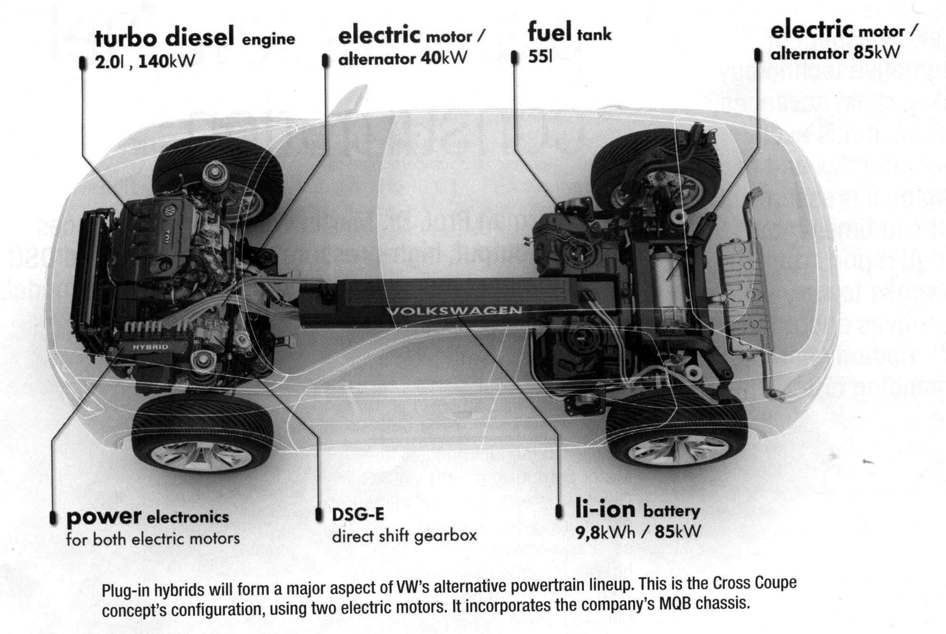

**Reading**

**Chairman Prof. Dr. Martin Winterkorn announces high-output, high-pressure diesel; a 10-speed DSG automated manual; and more plug-in hybrid models.**

Volkswagen’s belief in the future of the diesel engine, and its potential for still greater efficiency, was underlined at the International Vienna Motor Symposium, with VW AG Chairman Prof. Dr. Martin Winterkorn announcing that a variable-valve diesel engine delivering 100 kW (134 hp) per liter fitted with a high-pressure injection system of up to 3000 bar (34.5 ksi) is in development, as is a ten-speed

DSG (double-clutch) automated manual transmission. And all the company’s car classes will eventually be available with an electrical drivetrain10 component.

Outlining the VW Group’s future drive system technology plans, he also emphasized the significance of plug-in hybrids and natural gas as an alternative fuel.

Cutting fuel consumption is a continuing campaign for the company, said Winterkorn: “Since the year 2000, we’ve reduced the fuel consumption of our TDI (diesel) and TSI (gasoline) engines by more than 30%. I’m convinced that by 2020 we can achieve further increases in efficiency of around 15%.”

As with most OEMs11, Winterkorn sees various drive systems in parallel production – including hybrids and pure electric vehicles. The VW Group is committed to achieve the new car fleet CO2 emissions European requirement of 96 g/km by 2020.

Although many countries at present do not have the infrastructure for it, VW regards natural gas as having great promise. “We need to make the public even more aware of the benefits of natural gas engines,” Winterkorn emphasized.

He described natural gas as being environmentally friendly, economical, and suitable for everyday use. “The technology is fully developed and vehicles are already on the market,” he told the symposium. Using the fuel, the company’s eco-up! model achieves 79 g/km of CO2, positioning it as the world’s most economical natural gas car, he said. The VW Group will offer natural gas as a fuel solution via the golf TGI BlueMotion and the Audi A3 g-tron.

Aiding the variety of drive systems for VW will be the Group-wide Volkswagen MQB modular component system and its flexible architecture; this will enable “every kind of drive system” to be integrated quickly into the new models, stated Winterkorn: “Over the coming years, we wil electrify all vehicle classes in this way and help electrically powered motoring to make the breakthrough.”

As a medium-term technology, plug-in hybrid technology is the first choice for provision of an alternative drivetrain, he believes, because it delivers a purely electric range of up to 50 km (31 mi); a “high level” of suitability for everyday use thanks to recharging from a socket at home; and complete flexibility for long journeys via an efficient internal combustion engine.

The Group’s first plug-in hybrids to enter series production are a version of the Porsche Panamera and the Audi A3 e-tron. They will be followed by other models offering the technology, including the VW Golf and Passat, Audi A6, and Porsche Cayenne.

**I. Indicate whether the following statements are true (T) or false (F).**

1) VW plans to make all the company’s cars available with an electrical drivetrain component in the future.

2) VW has already reduced the fuel consumption of their diesel and gasoline engines by 15%.

3) VW thinks that natural gas is a promising type of alternative fuel.

4) The technology for gas-powered vehicles is not fully developed yet.

5) Electric vehicles are suitable and convenient for long journeys.

6) The Porsche Panamera is now available in a hybrid version.

**II. What do the following numbers refer to?**

* 96 g/km
* 50 km
* 3000 bar
* 2020

**III. Would you like to drive a hybrid car? List the benefits of a hybrid car.**

**Further reading**

http://auto.howstuffworks.com/fuel-efficiency/hybrid-technology/10-alternative-fuels-on-the-road1.htm#page=0

http://auto.howstuffworks.com/fuel-efficiency/alternative-fuels/afv-pictures.htm

**CARS OF THE FUTURE: AUTOMOTIVE INNOVATION**

**1. What is innovation? Look at the definition from Merriam-Webster Online Dictionary.**

|  |
| --- |
| in·no·va·tion  ***noun*** \ˌi-nə-ˈvā-shən\  : a new idea, device, or method  : the act or process of introducing new ideas, devices, or methods  **Full Definition of INNOVATION**  **1**  **:**  the introduction of something new  **2**  **:**  a new idea, method, or device **:**  novelty  — **in·no·va·tion·al**  *adjective*   1. She is responsible for many *innovations* in her field. 2. the latest *innovation* in computer technology 3. Through technology and *innovation*, they found ways to get better results with less work. 4. the rapid pace of technological *innovation* |

**2. Can you give any examples of recent technical (non-automotive) innovations?**

**3. Think about recent automotive innovations. Working with a partner, make a list of all the innovations you have heard about. Then share you list with the class and make a final list of innovations. Divide them into the following categories:**

* mechanical innovations (engine, brakes, etc.)
* electronic innovations (self-parking, remote control, etc.)
* safety innovations (airbags, sensors, etc.)
* ergonomic innovations (seat comfort, boot space, etc.)

**4. Read the text. What type of innovation is described?**

As strange as it may sound, the electric car of the future may get a boost from a new type of internal combustion engine. The free piston linear generator was developed by a team at the German Aerospace Center, tacked as a range extender for battery powered cars, producing electricity through the burning of readily accessible and quick-to-fill gas or liquid fuels for times when the grid-charged batteries have been depleted. The compact power plant features two pistons opposed to each other on either side of a single combustion chamber. Air springs that return them to center after the ignited fuel expands also act as generators that can power electric motors directly or re-charge a car's batteries. By eliminating the need for a crank case turning an external generator, the motor is both smaller and potentially more efficient than the internal combustion engines used in current plug-in hybrids like the Chevrolet Volt and Fisker Karma. The team behind it says the production version of the tube-shaped motor could weigh as little as 125 pounds and generate up to 40 horsepower. Several would be stacked together to increase power as needed. As an added benefit, the design allows the size of the combustion chamber and its compression ratio to be infinitely adjusted without having to change parts, allowing it to run on a variety of fuels, including diesel, natural gas and hydrogen. A representative for the Center says the free piston linear generator could be in production within four or five years if an industrial partner comes on board to commercialize it. In New York, Gehr Gasteluv, Foxnews.com.

**5. Read the text again. Describe the new ICE called “free piston linear generator” using the following words: *piston, combustion chamber, air spring, ignited fuel, expand*. Answer the following questions:**

1) Why is such a motor smaller than a usual ICE?

2) How much does it weigh?

3) What can we do if we need more horsepower than this motor can generate?

4) When are they planning to start producing these motors?

**6. What do you think cars will look like in 50 years? What will they be capable of? Look at what some people think and indicate whether you agree with them. Add your own ideas.**

**Oliver, 21, UK:** *I don't think that cars will change that much in design. They will carry on getting bigger, as they already are, and the engines will probably be replaced with more environmentally-friendly technology but people will still want the same kind of performance*.

**Filipp, 31, USA:** *Considering the revolutionary changes in vehicle design that have taken place in the previous 50 years, I would anticipate cars will evolve more slowly. I do believe we will see further advances in alternative fuel technologies, as well as continued integration of technologies such as mobile phones with vehicles. Additionally, light-weight materials such as aluminum will see more widespread use (also in an attempt to increase fuel economy). As far as the cars’ looks, however, I don’t expect major changes*.

**7. Read the article.**

**Plastic proliferation under the hood12**

**Before reading**

***1) Look at the title of the article. What do you understand it to mean?***

***2) Make a list of things made from plastic that you use every day.***

***3) What do you think about a car engine made from plastic? Do you think it would ever be feasible? What are the potential problems that have to be solved before a plastic engine becomes possible?***

***4) What are the main properties of plastic? Choose from the following list:***

low/high density

low/high heat-resistance

low/high vibration resistance

low/high cold resistance

low/high oxidation resistance

***What may be the difference between commodity plastics and engineering plastics?***

***5) Working in pairs, match the names of car parts with their Russian equivalents.***

|  |  |
| --- | --- |
| intake manifold | a) уплотнительное кольцо коллектор |
| oil pan | b) поддон картера |
| air filter housing | c) навинчиваемый фильтр |
| intake runner system | d) крепеж кулачкового зажима |
| throttle | e) рукоятка дросселя (регулятор подачи горючего) |
| spin-on filter module | f) поддон – отсекатель масла |
| gasket | g) впускной (всасывающий) |
| valve timing cam cover | h) маслоотборный патрубок |
| windage tray | i) кожух воздушного фильтра |
| drain plug | k) рабочее колесо водяного насоса |
| cam-lock fastener | l) система труб впускного коллектора |
| oil pickup tube | m) сливная пробка |
| water pump impeller | n) покрытие распределительного кулачкового вала |

***6) Choose the correct Russian equivalents using the words from the box.***

|  |  |
| --- | --- |
| плавиться уменьшаться осматривать ковать рассеивать расширяться проникать поглощать выдерживать ломаться закреплять заворачивать превосходить | |
| 1) absorb |  |
| 2) dissipate |  |
| 3) melt |  |
| 4) weld |  |
| 5) expand |  |
| 6) fasten |  |
| 7) tolerate |  |
| 8) inspect |  |

**Reading**

**Part 1**

Plastic has entered every aspect of our lives, displacing cardboard from box packaging, and paper from grocery bags. Even so, it must have surely seemed that parts like engine components would remain metal.

But improving plastic technology and the demand for reduced weight means that now we see plastic even in engine parts that carry some stress, such as intake manifolds and oil pans. You don’t have to look that far into the past to find stamped-steel air filter housings, a practically stress-free application.

Trouble is, it is hot under the hood of a car, and there tends to be a lot of vibration when the engine’s running. Of course, it can also get extremely cold. So factors that metal handles pretty well, like heat, cold, and vibration, tend to make it difficult to replace metal parts with lighter plastic ones.

Still, progress in materials and design means that plastic continues to be used in engine components. In General Motors’ high-feature V6 engine, for example, replacement of aluminum with a 35% glass-filled polyamide cut between 7 and 9 lb (3.2 and 4.1 kg) of weight.

The material has a density that is less than half that of aluminum and less than a third that of stamped steel, but unsurprisingly, the plastic must be thicker than those metals, so weight is not reduced by those same margins.

**I. Answer the following questions.**

1) What car parts that are utilized under stress are now being made from plastic?

2) What conditions that metal can resist well are a problem for plastic?

3) Is the density of aluminum higher than that of glass-filled polyamide?

4) Why must plastic be thicker than metals?

**Part 2. Not a direct substitute**

Replacing a metallic intake manifold with a plastic one brings a variety of issues. For example, a cast-aluminum intake manifold can be cast as one single part, which is a rather simple process.

A plastic card, in contrast, is made of several parts that must be welded together, making plastic more complicated to use. The tooling for these multiple parts and the need to weld them together make it more expensive to make plastic manifolds than to cast metal ones.

But while that complexity adds cost, it also contributes to the ability to make plastic manifold’s shape closer to ideal shape in plastic.

Additionally, air flows better through the smooth passages of molded plastic than through the rough surfaces of a cast-aluminum manifold. For the high-feature V6, GM saw a 3.5% improvement in airflow imbalance between cylinders was improved by 50% due to the plastic part’s optimized shape.

The additional work that goes into making the manifolds falls on the supplier companies that provide them to automakers. In GM’s case that means Sogefi SpA has to make multiple pieces and then weld them together to create the finished product. “From a parts standpoint, it is definitely more complex,” Vandyke noted.

Across the Pacific, Japanese fuel-system supplier Keihin supplies the plastic intake manifold for the 1.5-L four-cylinder in the Honda Fit. The part weighs only 4.25 lb (1.93 kg) without the throttle body assembly.

Hyundai’s 1.8-L “Nu” engine’s plastic intake manifold contributes a 15% cost savings and 30% less mass.

**I. Indicate whether the following statements are true (T) or false (F).**

1) A plastic intake manifold can be cast as one single part.

2) Welding is needed for making a plastic intake manifold.

3) Plastic makes intake manifolds more expensive, but allows for better balanced intake runner system.

4) Molded plastic manifolds passages are rough.

5) Keihin supplies the plastic intake manifolds for Hyundai.

**Part III. Working for the clampdown13**

A challenge for tightly clamped plastic parts is that they can deform when hot, reducing the clamping load on the part and potentially leading to leaks. Leaks can also arise due to the differing rates of thermal expansion of plastic parts and the metallic parts to which they are fastened. Metal inserts in the plastic surrounding the fastener help to solve this problem, though they add to the complexity.

Chrysler’s Pentastar V6 engine marks the first use of plastic for a variable valve timing cam cover, an application that is challenging because of the need for positional tolerance of 0.5 mm (0.02 in). Chrysler achieves this by inspecting all of the parts with a laser measurement tool at a special station on the assembly line. Switching to plastic cut 5 lb (2.3 kg) of weight from the engine.

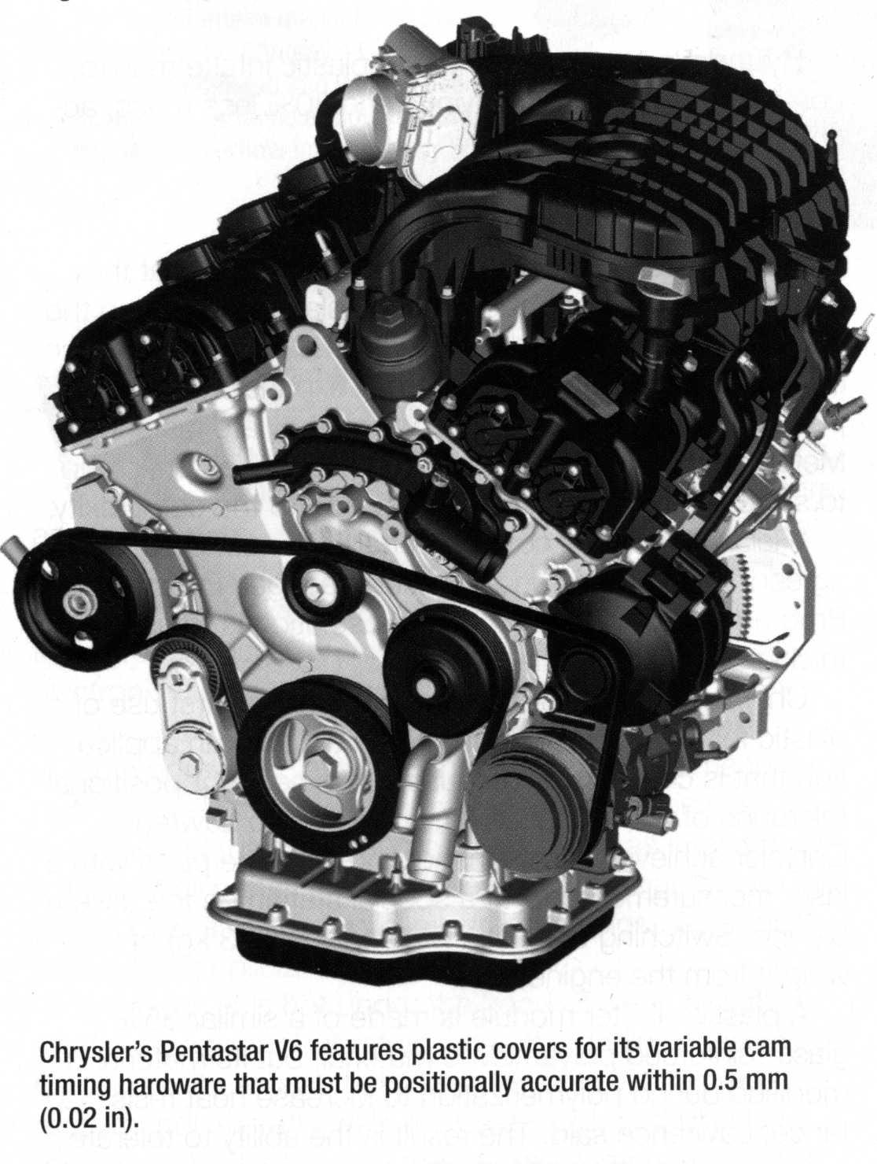

plastic oil filter module is made of a similar 35% glass-reinforced polyamide-6 material, but its material is modified during polymerization to increase heat resistance. The result is the ability to tolerate hot glycol at 130°C (266°F). The spin-on filter module can go directly into the engine, eliminating 148 parts, reducing weight by 43%, and cutting material cost by 60%.

**I. What do the following numbers refer to?**

* 2.3
* 0.5
* 60
* 130
* 148

**II. What is the main risk for the tightly clamped plastic parts?**

**Part IV. Impact resistance**

Oil pans are a good example of where plastic parts have taken on new importance. “At one point oil pans were completely non-stressed,” said Doug Skorupski, Product Marketing Manager at Volkswagen of America. “Now they are an integral part to the rigidity of the engine.”

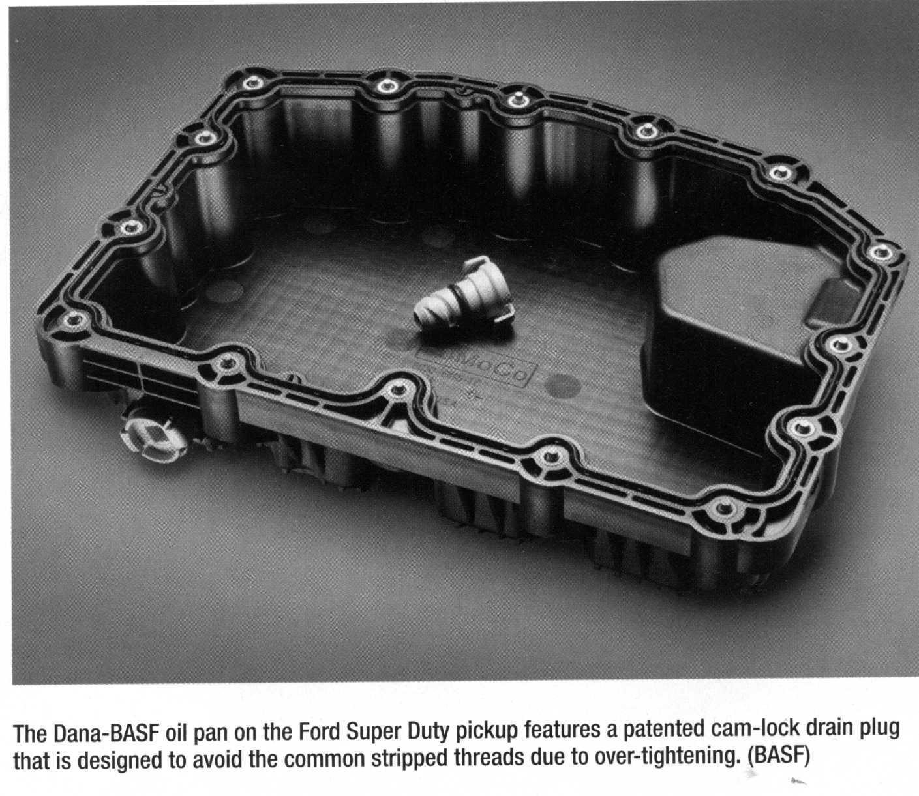

It can be tougher for a plastic part to serve as a structural member, so the surrounding metal parts must be designed to take more of the load than they would with a metal oil pan, he said: “You can’t just swap out the part without looking at the design of the motor.” The plastic part can also be reinforced with ribs to help too. Plastic oil pans are able to absorb impacts from road hazards that might crack a casting. Dana’s oil pan made with BASF Ultramid Optimized for Stone Impact thermoplastic has impact-absorbing properties. It relies on a network of ribs to dissipate impact energy. The part is used on Ford’s Super Duty pickup truck’s 6.7-L Powerstroke diesel engine.

Testing showed a plastic pan withstanding a stone fired into the pan at 60 mph (80 km/h). Additionally, a plastic pan can incorporate other parts, like a windage tray, oil pickup tube, and even the oil filter module.

The pan also addresses another routine oil pan problem: stripped threads in the hole for the oil drain plug due to over-tightening. In place of the usual steel bolt, the Super Duty’s plastic oil pan has a plastic drain plug with a cam-lock fastener that lets it be tightened by hand or with a 3/8-in socket.

Resistance to chemicals is another factor in using plastic in the hostile underhood environment. It is critical that the part maintain integrity after exposure to various chemicals. But it is also important that the part resist discoloration so it preserves acceptable appearance, he said.

Thermostat housings, water pump impellers, and still more parts are continuing the shift toward plastic.

**I. Indicate whether the following statements are true (T) or false (F).**

1) Plastic oil pans do not need any reinforcement.

2) Plastic oil pans are usually made from impact thermoplastic.

3) Aluminum has better impact-absorbing properties than impact thermoplastic.

4) A plastic drain plug is often over-tightened.

5) Plastic is good for use in hostile under-hood environment because of its resistance to chemicals.

**8. What other (not mentioned in the text) car parts may be made of plastic?**

**9. Think about potential disadvantages of using plastic in car building. What are they?**

**Further reading**

http://www.raeng.org.uk/news/publications/list/reports/Innovation_in_automotive_report.pdf

http://auto.howstuffworks.com/under-the-hood/trends-innovations/5-future-car-technologies.htm

http://www.autoalliance.org/auto-innovation/2014-innovation-report

**CARS OF THE FUTURE: TROUBLES AND DANGERS**

**1. Do you think a totally computerized, driverless car is a real possibility? Would you like it to become a reality?**

**2. Give examples (from fiction or films, either Russian or foreign) of cars operating on their own, fully computer-controlled.**

**3. Working in pairs, make a list of benefits and potential dangers of driverless cars.**

**4. Do you think it is safe to drive an "intelligent", i.e. totally computer-controlled, car? Why? Look at what some people think and indicate whether you agree or disagree with their opinions.**

**Oliver, 21, UK:** *Computer controlled cars will probably be perfectly good but I could never trust one. My computer goes crazy and gives me error messages just opening my emails, a Word document and iTunes at the same time. Would I really want to be in an equally unreliable metal box travelling at 90mph? Besides, I like driving*.

**Filipp, 31, USA:** *While I recognize the technological advances that have made driverless cars possible, for someone like myself (a “driver” vs. a “commuter”) “intelligent” cars are a travesty and a nuisance rather than a convenience. I don’t even like using cruise control in my cars (to say nothing of preferring manual transmissions) as it makes me feel like the car is in control more so than me - I don’t like that*.

**5. Read the article.**

**Counteracting cyber-attacks14**

**Before reading**

**1) Match the words with the Russian equivalents.**

|  |  |
| --- | --- |
| 1) cyber-security | a) уязвимость |
| 2) cyber-attack | b) кибербезопасность |
| 3) automotive system (vehicle system) | c) аппаратное обеспечение |
| 4) software | d) кибератака |
| 5) vulnerability | e) программное обеспечение |
| 6) hardware | f) автомобильная (компьютерная) система |

**2) Do the following things belong to the category of software or hardware?**

graphic card, word processor, Adobe Photoshop, motherboard, sound card, AutoCAD

**3) What is a CPU?**

*CPU is the hardware within a computer that carries out the instructions of a computer program by performing the basic arithmetical, logical, and input/output operations of the system*.

What is the Russian word for CPU?

**4) Look at the picture. What is that?**

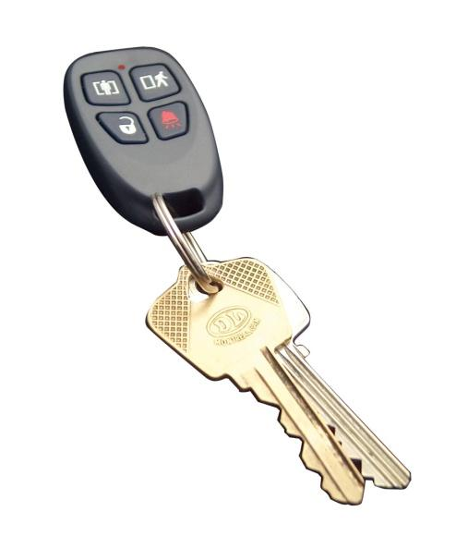

A fob, or what is more commonly called a ***key fob***, is a small security hardware device with built-in authentication used to control and secure access to network services and data. The key fob displays a randomly generated access code, which changes periodically, usually every 30 to 60 seconds. A user first authenticates himself on the key fob with a personal identification number (PIN), followed by the current code displayed on the device.

Key fob is also a term used to describe a key chain and several other similar items and devices. The word fob is believed to have originated from watch fobs, which existed as early as 1888. The fob refers to an ornament attached to a pocket-watch chain. Key chains, car starters, garage door openers, and keyless entry devices on hotel room doors are also called fobs.

**Do you use a key fob? What are the potential dangers of using a key fob?**

**Reading**

**As vehicle systems become more complex and interact with more internal and external elements, the potential for outside intrusion and tampering increases for both vehicles and the transportation infrastructure.**

**Part I.**

Today’s vehicles contain a number of systems designed to help improve overall vehicle safety and performance. These systems may control essential vehicle functions such as steering, braking and/or propulsion, and much emphasis is being placed on insuring the cyber security of these critical automotive systems. A security-critical automotive system is one in which losses could occur due to vulnerabilities that could be exploited either directly or indirectly by either an external or internal individual (or group).

As awareness of cyber security in the automotive industry increases, and as vehicle systems become more complex and interact more tightly with both the physical elements of the vehicle and the physical environment around the vehicle, they are now more frequently being classified as cyber-physical systems.

In a cyber-physical system there exists a tight coupling between its computational and physical elements and the environment around the system. The systems are becoming more tightly coupled both for vehicle-to-vehicle and vehicle-to-infrastructure scenarios.

This interconnectivity creates the potential for cyber-attacks on vehicles and the transportation infrastructure supporting them and their use (e.g., Intelligent Transportation Systems). Cyber-attacks on security-critical cyber-physical automotive systems could lead to potential safety, operational, financial and privacy losses.

Safety cannot be added on to an existing design but rather must be built into it. This can be done by following and applying a well-structured and well-defined system safety engineering process.

**I.** **Answer the following questions.**

1) What is a security-critical automotive system?

2) Why are vehicle systems often classified as cyber-physical systems?

3) What is interconnectivity?

**Part II. Motive for attack**

Security in the general IT area is more widely known, and some of this knowledge and experience can be transferred into the automotive area; however, there are some significant cyber security differences between IT and cyber-physical automotive systems.

For example, security of cyber-physical systems needs to address sensors and actuators15 that interact with the environment around the system; so unlike IT systems, security of cyber-physical systems must also consider the environment around the control system and cyber-physical system. This difference leads to different security counter-measures for cyber-physical systems than for IT systems.

There are a variety of ways today’s vehicles are connected to extra-vehicle media, including Bluetooth, CDs, USBs, etc. Some vehicles today, and more vehicles in the future, will not only be connected to extra-vehicle media but also to other vehicles and vehicle infrastructure. This present and future interconnectivity creates the potential for cyber-attacks on vehicles and vehicle infrastructure.

Given that potential safety, privacy, operational and financial losses may occur as the result of an attack either directly or indirectly on vehicles and/or infrastructure, it is desirable to perform activities to reduce the likelihood of a successful attack.

Examples of potential losses in each of the categories associated with attacks on vehicles include:

* Safety – a vulnerability that allows access, either directly or indirectly, to a safety-critical system
* Operational – a vulnerability that allows access, either directly or indirectly, to a non-safety-critical system that leads to a denial of service of that operation
* Financial – a vulnerability that allows multiple systems to be compromised; warranty fraud is another example
* Privacy – a vulnerability that allows personal information to be compromised or that allows personal conversations in the vehicle to be monitored.

**I. Answer the following questions.**

1) Is there any difference between general IT security and automotive cyber-security?

2) What exactly creates the potential for cyber-attacks on vehicles and vehicle infrastructure?

3) What kinds of vulnerabilities exist within automotive systems?

**Part III. Growing concern**

The topic of automotive security is not new to chip maker Infineon Technologies, which has been implementing additional security functions in some of its products since 2005 to protect the engine microcontroller against tuning.

“We are seeing now stronger awareness,” said Bjorn Steurich, Senior Manager of the Automotive Systems Group at Infineon Technologies. “We started a special project that I’m leading within Infineon between our automotive business line and our chip card and security business line that goes back to mid-2011. We started talking to the OEMs16 to better understand what are their concerns and what are the needs in the different regions. And then, we tried to map out how far they are in their differences, and we tried to understand the use cases, and then we more deeply analyzed these use cases.”

Steurich noted that at the outset of the program in 2011, U.S. automotive OEMs were already starting to show concern about potential cyber-attacks, while European OEMs were still mainly focused on the issue from a fraud and anti-theft standpoint, with German department estimates of annual damage to the end consumer in the €5 billion range.

As a result of its research, Infineon began classifying attacks on vehicle security controllers into four classes – manipulative, semi-invasive, observing and logical.

“There are classes of attacks where somebody could try to just observe, for example, the power consumption and can extract the secret of the parts,” said Steurich. “One could even try to tamper, for example, with the power supply or the clock supply of the part to bring the part out of the normal operation. So there are different classes of attacks, and it’s a matter of the investment, the equipment, that you are willing to spend for an attack. A big step in automotive is already to use this to protect against logical attacks and to use… better ECU17 individual keys. So if you hack one, the damage is not too high.”

**I. Answer the following questions.**

1) What does the word “awareness” mean?

2) Why did Infineon Technologies “start to talk more to the OEMs”?

3) What classes of cyber-attacks does Infineon recognize?

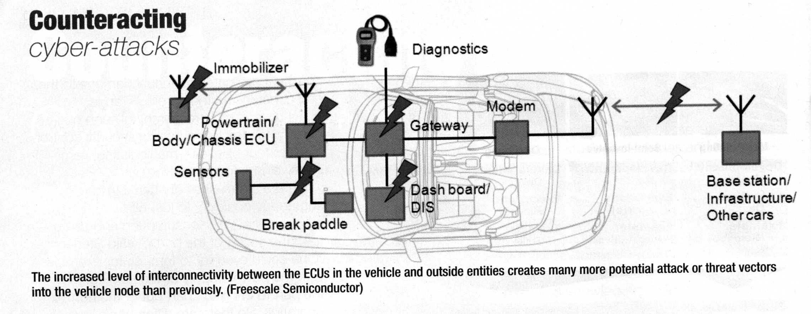

**Part IV. Built-in protection**

Building safety and security into a design at the outset rather than attempting to add it later to an existing design is important when addressing the topic of cyber security.

“Prior to the past five years, security wasn’t really considered in the design of the deeply embedded microcontrollers that are used in a vehicle,” said Richard Soja, Systems Engineer-Automotive MCU Division, Freescale Semiconductor. “There was very little interconnectivity, either between the ECUs in the vehicle or to outside entities; the only real interconnectivity was to the remote key fob. So that was really the only motivating factor for security at one time. But now, of course, the vehicle is just becoming a node in that system. There are many more potential attack or threat vectors into the vehicle node than there used to be. So we now have to consider other methods of preventing two things: one is unauthorized access, and the other is detecting whether anything has been changed that shouldn’t be changed.”

On its most recent microcontrollers, Freescale has implemented mechanisms that include hardware detection of flash memory tampering. Hardware security modules are also integrated into the microcontrollers that can be used to set up a root-of-trust type of architecture to verify the authenticity of any code that is executed prior to its running.

“So that means that we can detect if someone has installed bogus code and code that has some malicious behavior or properties, and prevent that code from running,” Soja said.

From a software perspective, operating system providers such as QNX Software Systems are working closely with CPU manufacturers to ensure that customers are using the CPU most effectively to protect the boot sequence, for example, from potential attack.

“The whole thing about security is not just protecting against active attacks but also to ensure that it’s very, very difficult for people to analyze the systems as well,” said Andy Gryc, Senior Automotive Product Marketing Manager, QNX Software Systems. “I don’t think that fundamentally our products will change; I think what will change probably for us is to really make sure that we do a good job of educating our customers on how to properly use our technology. Because the technology is already there and it’s already sound, but there’s no way to really guarantee that people are doing things in an appropriate way unless you actually make sure that they’re aware of the risks. I think at this point, people are aware of the risks, so that education process will be a lot easier for us now.”

**I. Answer the following questions.**

1) What was the only “real interconnectivity” five years ago?

2) What does QNX Software Systems do or produce?

3) Why is customer awareness important?

**NOTE**

OEM (*pronounced as separate letters*) is short for ***o****riginal****e****quipment****m****anufacturer*, which is a misleading term for a company that has a special relationship with computer producers. OEMs are manufacturers who resell another company's product under their own name and branding.

While an OEM is similar to a VAR (***v****alue-****a****dded****r****eseller*), it refers specifically to the act of a company rebranding a product to its own name and offering its own warranty, support and licensing of the product. The term is really misleading because OEMs are not the original manufacturers; they are the customizers.

**After reading**

**1) Indicate whether the following statements are true (T) or false (F).**

1) Most automotive systems now are designed to improve vehicle safety.

2) Safety of an existing vehicle design may be easily upgraded.

3) Potential losses resulting from a cyber-attacks on security-critical cyber-physical automotive systems include safety, operational and financial losses.

4) U.S. automotive industry realized the danger of cyber-attacks earlier than the European auto business.

5) When somebody hacks the system just to have a look at it, it is not considered to be a cyber-attack.

6) Microcontrollers can detect illegally installed codes on car computers.

7) People don’t have to know the cyber-security risks as car manufacturers take care of all the risks themselves.

**2) Match the following words with the definitions/synonyms.**

|  |  |
| --- | --- |
| 1) unauthorized | a) built-in |
| 2) malicious | b) threat |
| 3) bogus | c) without permission |
| 4) embedded | d) fake |
| 5) hazard | e) bad, harmful |

**3) Give the main points mentioned in parts I-IV of the text.**

**Further reading**

http://auto.howstuffworks.com/under-the-hood/aftermarket-accessories-customization/10-car-security-systems.htm

http://www.secunet.com/en/topics-solutions/

**PRESENTATION OF A CAR**

**1. What do you absolutely need to know about a car before you buy it? And what additional non-critical things would you like to know?**

**2. Look at the following list of things to be considered before buying a car. Choose your own top-5. Can you add anything else to this list?**

price

performance

fuel efficiency

style/design

boot space

safety

connectivity (onboard computer, satellite navigation, etc.)

color

automatic/manual transmission

make (марка автомобиля)

country of assembly

inner space

variety of available features

size (of a car)

top speed

horsepower

**4. Look through a magazine’s review of the Ford Focus. Fill in the gaps with the following headings:**

* Reliability
* Styling
* Driving
* Running costs
* Practicality

The Ford Focus is the best-selling family hatch in the UK, and with good reason. There’s a wide range of models, from basic to high-performance, while the turbo petrol and diesel engines deliver decent running costs.

This latest third-generation Ford Focus provides supreme quality, comfort and handling - a true rival for the Volkswagen Golf.

Those wanting more space have the option of the Ford Focus estate, too. Unusually, the estate version of the Ford Focus actually drives just as well as the hatch.

The Ford Focus is available in six main specifications18 – entry-level Studio and Edge, mid-range Zetec and Zetec S and top-of-the-range Titanium and Titanium X. Meanwhile, those who want a little extra performance should opt for the excellent ST hot hatch – a great alternative to the VW Golf GTI and Renaultsport Megane.

The Ford Focus features economical diesel and smooth petrol engines. We'd opt for the popular three-cylinder turbocharged EcoBoost petrol engine, which strikes a balance between lively performance and low running costs.

1) ________________________________

You can’t call the Ford Focus pretty. The mix of angles and curves up front looks awkward when compared to the SEAT Leon, and even the Renault Megane’s revised front end is more cohesive.

The rest of the car follows a standard hatchback template, although the roofline is slightly longer than its rivals’. At the back, designers have neatly integrated the fuel filler flap with the right-hand tail-light, although the plastic flap on our car was poorly fitted.

Inside, the Focus features a sculpted centre console with a small 3.5-inch display and a large bank of buttons below that’s flanked by vertical air vents.

Overall, the Focus is well built, and the quality of the switchgear is great – we just wish there weren’t so many buttons and that the sat-nav19 screen was larger.

2) _____________________________

The Ford Focus has clearly been designed with comfort and efficiency in mind, but having said that it's still an enjoyable ride. It's certainly more exciting to drive than a Vauxhall Astra, and definitely on par with the Volkswagen Golf thanks to sharp steering, an agile chassis and strong grip.

The Focus’s 1.0-litre EcoBoost engine suits its sporty nature. The engine is settled at motorway speeds and doesn’t spoil cabin comfort, while the suspension does a good job of soaking up bumps.

3) _______________________________

When you consider how many Focuses have been sold, it appears to be a fairly reliable car. Owners aren’t greatly enamoured with it, which is why the model dropped from 19th place in the Driver Power 2012 survey to 70th in 2013 – but there are no major issues that potential buyers need to be aware of. Owners like how the Focus drives and the technology it offers, although a 29th place finish for Ford’s chain of 700-plus dealers isn’t great.

Ford’s safety technology helped the Focus earn a five-star Euro NCAP crash test rating. You get six airbags and ESP as standard, while the Zetec model includes handy extras such as heated mirrors and a Quickclear heated windscreen.

4) _______________________________

The Focus isn’t the most practical compact hatch on the market. While its dimensions are on the large side in this class, the car is small inside.

At the back, you get a 316-litre boot – 89 litres down on the Renault Megane – and this only rises to 1,101 litres with the seats flat. That’s 109 litres behind the SEAT Leon, although a shallow floor makes it easy to unload big items.

Rear seat space is reasonable, although the small back windows and sloping roof line make the Ford feel tighter than its rivals. There’s a decent glovebox, door bins and cup-holders.

5) ________________________________

If you don't count the sporty Ford Focus ST, every car in the line-up emits less than 140g/km of CO2, which is pretty good if you consider how large the engine range is.

The latest Ford Focus is lighter than ever before and as a result it's cheaper to run, too. Highlights in the range include a 1.0-litre EcoBoost engine, which manages 58.9mpg and emits only 109g/km of CO2, but the reality is that you would have to drive extremely cautiously to achieve this. Standard stop-start does help, and we managed 43.4mpg on test.

**5. What cars are named as the Ford Focus’s potential competitors?**

**6. Match the following words with their definitions.**

|  |  |
| --- | --- |
| cost-effective | designed not to harm the natural environment |
| environmentally friendly | of very high quality |
| modern | working in a way that does not waste fuel |
| advanced | designed to be very fast and powerful |
| fuel-efficient | consistently good in quality or performance |
| supreme | characteristic of present and recent time |
| reliable | giving the most profit or advantage in exchange for the amount of money that is spent |
| high-performance | based on the most recent methods or ideas |

**7. Which things in the advert did you find the most attractive? Why?**

**8. Listen to the presentation on the Kia Soul. Put the following in the correct order (as it is discussed in the presentation):**

* marketing
* technical details
* style
* general information about the car
* rivals

**9. Match the words from the presentation with the parts of the presentation listed above:**

* overview
* under the hood
* design
* competition
* commercial

**10. Who are Kia Soul’s target customers? And who actually buys the car?**

**11. Fill in the gaps in the sentences with the words from the box.**

|  |
| --- |
| comes successful combine shape options package manual unusual available standard improved premium range released |

1. Cars in this segment 1) _______________ the features of both compact hatchbacks and traditional SUVs in a smaller 2) ____________________.
2. It was originally 3) _________________ in 2009 and was quite 4) __________________.
3. Kia then 5) __________________ the original car and the new Soul was introduced in 2013.
4. The Soul 6)______________ in three different trim levels.
5. Under the hood, the Soul has a choice of two four-cylinder engine 7) ______________ – a 1.6L with 138 horsepower and a more powerful 2.0L with 164 horsepower.
6. Buyers can choose either a 8) _________________ or an automatic transmission.
7. What made the original Soul so popular were its 9) _______________ design, its boxy 10) __________ and bold colors.
8. Inside, the Soul is 11) ___________________ in both light and dark colors and comes

12) ____________ with power windows, phone integration via Bluetooth and 13) _________________ materials both in the seats and on the dashboard.

1. Its competitors 14) ___________________ from the traditional small cars such as the Ford Fiesta to small SUVs such as the Nissan Juke.

**Further reading**

http://usnews.rankingsandreviews.com/cars-trucks/Toyota_Corolla/

http://www.independent.co.uk/life-style/motoring/road-tests/motoring-review-renaults-dacia-logan-is-an-immigrant-that-even-finchy-would-admire-8899898.html

**Presentation Phrasebook**

**Greeting your audience, introducing yourself and giving the topic of your presentation**

*Good morning. My name’s ............. and I’m going to talk about ...*

*Good morning everybody. Thank you for coming to my talk today. My name is …… and I’m from ...*

*Hello. I’m .............. and welcome to my presentation about ...*

*Hello. My name’s .................... and today I’m going to be talking about ...*

**Giving the outline of your presentation**

*Firstly, I’m going to look at ...*

*Secondly, I’ll move on to the issue of ...*

*Then I’ll move on to examine ...*

*Lastly/Finally, I’ll look at / focus on ...*

*I have divided my talk into the following main areas: ...*

*I am going to divide my presentation into two main parts. First I’m going to describe …*

*and then I’ll move on to look at …*

*We’ll finish off with a question and answer session.*

*My talk will last about ........... minutes and there’ll be time at the end for questions.*

*At the end of my talk, which will last about ten minutes, I’ll be happy to answer any questions you may have.*

*If you have any questions please do not hesitate to ask.*

*Please just put your hand up if you would like to ask a question.*

**Introducing your first main point**

*Now, I’m going to start by …*

*Now I’d like to focus on …*

*First we’re going to look at …*

*Let’s start with …*

***Moving on***

*OK, so now I’d like to turn to my next point, which is ...*

*Moving on, I’d like to take a look at ….*

*Now I’d like to move on to ...*

*Now let’s turn to the issue of ...*

*I’ll come back to that issue later...*

*I want to turn now to*...

*Turning now to ...*

*Moving on now to ...*

*Having looked at ….. let’s now think about ...*

*My next point is in regards to …*

*That brings me to …*

*My final point is in regard to…*

**Making conclusions and summarising your main points**

*To conclude my presentation,*...

*In conclusion, ...*

*To summarise the main points of my presentation …*

*In view of the evidence I have presented I think it is fair to say that …*

*After all is said and done I think we can conclude that …*

*This is clearly a very complex issue but on the strength of the evidence I have seen I would say that …/it seems that …*

**Finishing your presentation**

*OK we’re coming to the end of the presentation so I’d just like to thank you for listening ...*

*OK. That bring us to the end of my presentation.*

*Thank you for listening.*

*I hope you found it interesting.*

**Asking for questions**

*Would anyone like to ask any questions?*

*I’m ready to take any questions now.*

*If anyone has questions I’ll be happy to answer them.*

**Answering questions**

*Thanks for your question ...*

*Good question. I think ...*

*That’s an interesting question! As I see it ...*

*Yes, that’s an interesting point ...*

**Dealing with difficult questions**

*Hmm, that’s a good question. I don’t have the information to answer that question right now, but I’d be happy to find out and get back to you later.*

*I don’t think we have enough time to go into that right now, but I’ll be happy to speak to you one-to-one after the presentation if you would like.*

**Asking questions to the presenter**

*Excuse me. Can you say a bit more about ...*

*Can you repeat your point about ...*

*Excuse me. I have a question about ...*

*I didn’t catch what you said about .... Can you repeat it please?*

*Are you saying that ...?*