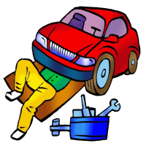

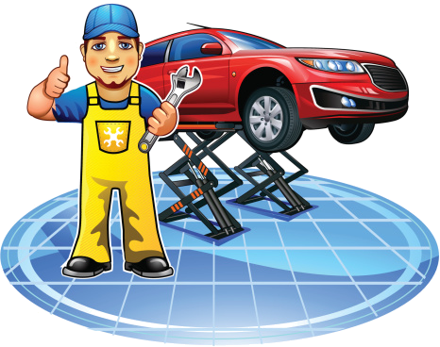
An auto mechanic (automotive technician in most of North America, car mechanic in British English and motor mechanic in Australian English) is a mechanic with a variety of automobile makes or either in a specific area or in a specific make of automobile. In repairing cars, their main role is to diagnose the problem accurately and quickly.
They often have to quote prices for their customers before commencing work or after partial disassembly for inspection. Their job may involve the repair of a specific part or the replacement of one or more parts as assemblies.
Basic vehicle maintenance is a fundamental part of a mechanic's work in modern industrialized countries while in others they are only consulted when a vehicle is already showing signs of malfunction. Preventative maintenance is also a fundamental part of a mechanic's job, but this is not possible in the case of vehicles that are not regularly maintained by a mechanic. One misunderstood aspect of preventative maintenance is scheduled replacement of various parts, which occurs before failure to avoid far more expensive damage. Because this means that parts are replaced before any problem is observed, many vehicle owners will not understand why the expense is necessary.
With the rapid advancement in technology, the mechanic's job has evolved from purely mechanical, to include electronic technology. Because vehicles today possess complex computer and electronic systems, mechanics need to have a broader base of knowledge than in the past.
Due to the increasingly labyrinthine nature of the technology that is now incorporated into automobiles, most automobile dealerships and independent workshops now provide sophisticated diagnostic computers to each technician, without which they would be unable to diagnose or repair a vehicle. https://en.wikipedia.org/wiki/Auto_mechanic

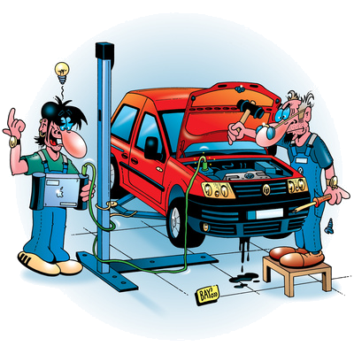

Now complete the sentences with one of the following words.

2.

A car mechanic has the same name everywhere. ____
He always performs the same task. ____
One of his/her tasks is to diagnose the problem. ____
Car mechanics have to inform the client of the price of the repair. ____
Basic vehicle maintenance is done by other professinals. ____
Sometimes they have to replace some parts of the car. ____
The mechanic’s job has remained the same for many decades. ____
Thanks to computers, mechanics only need to know a lot about cars. ____
Computers are being used to help the mechanic to diagnose the problem with the car. ____
Read the text and say if the statements are TRUE or FALSE. correct the false sentences.
1.

Bonnet / headlight / tire / fog-lamp /windscreen wiper / boot / number plate / steering wheel / bumper /
- As it was raining a lot we had to turn on the _________________________.
- We arrived late because we had a flat ________
- Put your luggage inside the ____________!
- I think you should switch on the _____________ because we can’t see the road. It’s too foggy.
- When the car mechanic arrived, he had to open the __________________ to find out why the car engine wasn’t functioning.
- The police officer introduced the ______________________________ of the car in the computer to find out who was the owner.
- When I saw the other car coming in my direction, I turned the _____________________ to the right to avoid the crash.
- If it is dark, you have to switch on the ___________________________.
- When I was backing into a parking space today, I ended up hitting the _____________________ of another car.

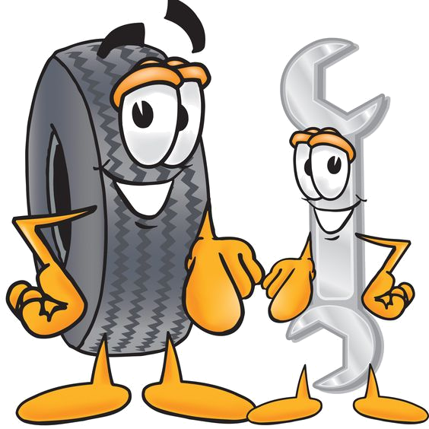

Match the numbers with the words on the right.

3.
____ cigarette lighter
____ accelerator
____ ignition
____ brake
____ dashboard
____ clutch
____ gear lever
____ glove compartment
____ sun visor
____ speedometer
____ vanity mirror
____ rear-view mirror
____ steering wheel
____ parking lights
____door handle
____ roof
____ bumper
____ radiator
____ fog light
____ headlight
____tyre / tire
____door
____ battery
____ trade mark
____ engine
____ windshield / windscreen
____ bonnet / hood
____ license plate / numberplate
____ radiator grille
____ fender / mudguard
____ boot / trunk
____ hub cap
____ seat belt
____ mirror
____ seat
____ windshield wiper

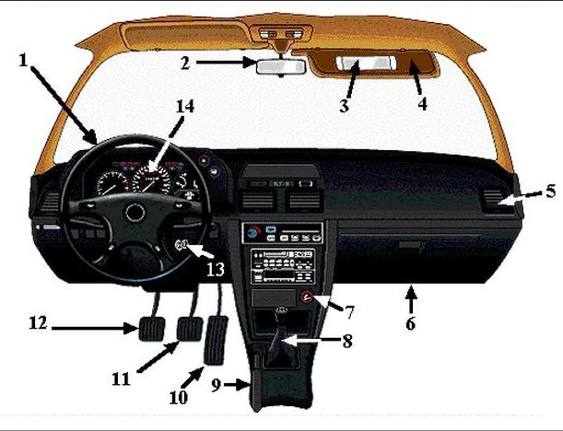

9

20
19
18
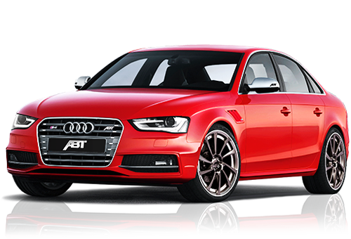
16
21
17
15
22

23

31
30
27
29
28
25
24
26
34
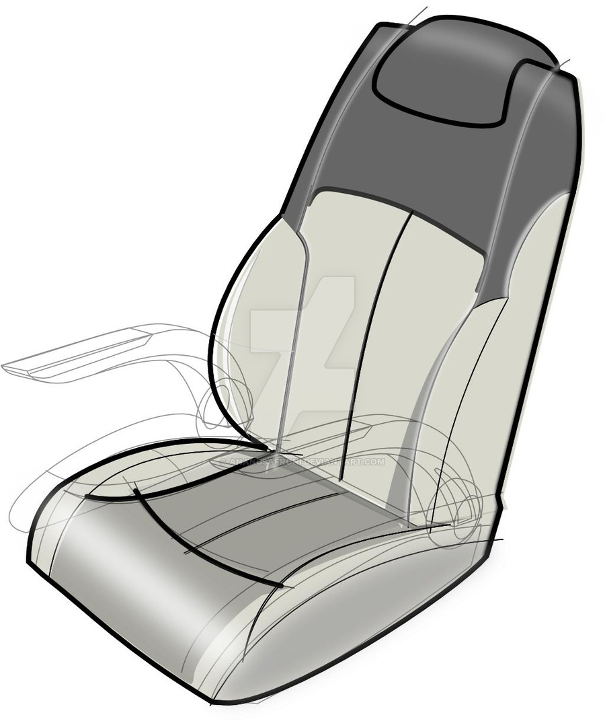
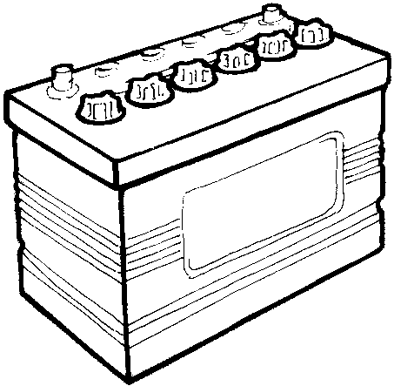
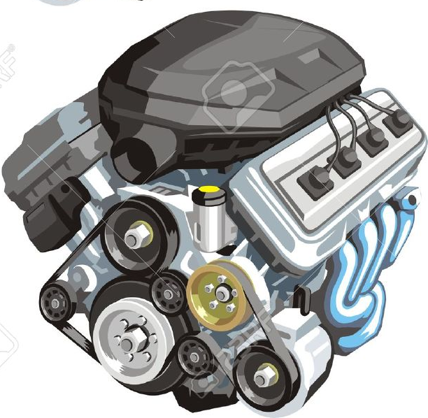
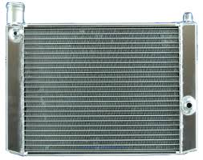
32
33

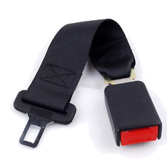
36

35

Name: _____________________________________ Class: _______ N. : _____
Teacher: ___________________

Read the text and say if the statements are TRUE or FALSE. correct the false sentences.

- A car mechanic has the same name everywhere. False. It has different names in American english and Australian English.
- He always performs the same task. False. He does different things.
- One of his/her tasks is to diagnose the problem. True
- Car mechanics have to inform the client of the price of the repair. True
- Basic vehicle maintenance is done by other professinals. False. It is also done by the car mechanics.
- Sometimes they have to replace some parts car parts. True
- The mechanic’s job has remained the same for many decades. False. It has evolved a lot because of technology.
- Thanks to computers, mechanics only need to know a lot about cars. False. They have to have a broader knowledge.
- Computers are being used to help the mechanic to diagnose the problem with the car. True

Now complete the sentences with one of the following words.

Match the numbers with the words on the right.

3.

Bonnet / headlight / tire / fog-lamps /windscreen wiper / boot / number plate / steering wheel / bumper /
- As it was raining a lot we had to turn on the windshield wiper / windscreen wiper.
- We arrived late because we had a flat tyre / tire.
- Put your luggage inside the boot / trunk!
- I think you should switch on the fog-lamps because we can’t see the road. It’s too foggy.
- When the car mechanic arrived, he had to open the bonnet to find out why the car engine wasn’t functioning.
- The police officer introduced the license plate / numberplate of the car in the computer to find out who was the owner.
- When I saw the other car coming in my direction, I turned the steering wheel to the right to avoid the crash.
- If it is dark, you have to switch on the headlights.
- When I was backing into a parking space today, I ended up hitting the bumper of another car.

__7__ cigarette lighter
__10__ accelerator
__13__ ignition
__11__ brake
__9__ dashboard
__12__ clutch
__8__ gear lever
__6__ glove compartment
__4__ sun visor
__14__ speedometer
_3__ vanity mirror
__2__ rear-view mirror
____ steering wheel
____ parking lights
____door handle
____ roof
____ bumper
____ radiator
____ fog light
____ headlight
____tyre / tire
____door
____ battery
____ trade mark
____ engine
____ windshield / windscreen
____ bonnet / hood
____ license plate / numberplate
____ radiator grille
____ fender / mudguard
____ boot / trunk
____ hub cap
____ seat belt
____ mirror
____ seat
____ windshield wiper

__1__ steering wheel
__5__ parking lights
__21__door handle
_20__ roof
__28__ bumper
__36__ radiator
_27__ fog light
__15__ headlight
_24__tyre / tire
__25__door
_34_ battery
__31__ trade mark
____ engine
____ windshield / windscreen
____ bonnet / hood
____ license plate / numberplate
____ radiator grille
____ fender / mudguard
____ boot / trunk
____ hub cap
____ seat belt
____ mirror
____ seat
____ windshield wiper

__33__ engine
__18__ windshield / windscreen
__16__ bonnet / hood
_30_ license plate / numberplate
_29__ radiator grille
_26__ fender / mudguard
_22__ boot / trunk
__23__ hub cap
_35__ seat belt
_17__ mirror
_32__ seat
__19__ windshield wiper

